February 2021
Virtual Meeting Presentation Handout

Tank Mix Template for Developing a Weed
Control Program in Potatoes
Pamela J.S. Hutchinson
University of Idaho
Potato Cropping Systems Weed Scientist
Aberdeen R&E Center

Tank Mix Template for Developing a Weed Control Program in Potatoes.
An effective way to improve weed control in each field is to customize the herbicide tank mixture to target the specific weed species in the field. Creation and use of a Herbicide Tank-Mix Partner Chart will allow for customizing a mixture for one field, then ability to change the herbicides for a different field with different weed species.
How to create a Herbicide Tank-mix Partner Chart:
- List Potato herbicides grouped by Site of Action (SOA) on the left (CHART 1).
  - Readily available charts organized in this manner can be found online.
- Enter across the top as many weed species as possible known to be in the potato production area.
- Enter the herbicide control levels for each weed (Tables 1 and 2). Weed control tables are also available in the PNW Weed Control Handbook and other publications that can be found online) (CHART 2).
- Select the weeds species known to be in the field of interest.
- Note the herbicides providing 90 to 100% control of those weeds.
- Choose two or more herbicides providing 90 to 100% season-long control of all the species in that field…that is the Targeted Tank Mix for the field.
  - Herbicides must have different SOA
  - Choose herbicides that have activity on more than one of the species = overlapping control of weed species present in the field.
This handout provides that information and more to customize herbicide tank mixtures depending upon the weed species present in a potato field i.e. Targeted Tank Mixtures.

BONUS:
See Table 3 at the end of the handout for Potato Herbicide Application Timing and Activity (soil and foliar).
and
Tables 4, 5 and 6 for Potato Herbicides Strengths and Challenges.
Tank Mix Partner Choice Chart 1: basic chart with control not yet indicated. Herbicides labeled for use in potatoes and Site of Action (SOA) are in the two left columns. Herbicides with the same color and number are in the same SOA group. In this chart, up to seven weed species that are the field could be listed across the top.
TANK MIX PARTNER CHOICE CHART
 |  | Weed species present
MOA Group # | Herbicides¹ | WEED 1 | WEED 2 | WEED 3 |  | WEED 4 | WEED 5 | WEED 6 | WEED 7
14 | Chateau (flumioxazin)
14 | Sulfentrazone (various names)
14 | Reflex (formesafen)
15 | Outlook (dimethenamid-p)
15 | Dual Magnum/  Dual II Magnum²  (s-metolachlor)
15 | Metolachlor  (various names)
15 | Zidua (pyroxasulfone)
2 | Matrix (and others)  (PRE or POST)
2 | Prism² (rimsulfuron (POST only)
8 | Eptam (EPTC)
3 | Prowl H2O (and others) (pendimethalin)
3 | Sonalan HFP (ethafluralin)
3 | Treflan HFP (trifluralin)
5 | Metribuzin (various names)
7 | Linex/Lorox (linuron)
15 + 5 | Boundary (s-metolachlor  + metribuzin)
5 + 14 | Sencor STZ² (Canada)  Sulfentrazone MTZ  metribuzin sulfentrazone
1 | Poast Plus or Ultra (sethoxydim)  Select (clethodim)  Venture² (fluoxifop-p-butyl)
Herbicides in the same color are in the same SOA group.
¹Not all registered product names are shown.
² Product labeled and sold in Canada, only.
NOTE: Burndown herbicides, glyphosate, paraquat, Sequence (glyphosate + s-metolachlor), and Aim (carfentrazone-ethyl) are not included but may be needed as part of the herbicide control program.

Tank Mix Partner Choice Chart 2: with herbicides labeled for use in potatoes in the left column. Herbicides in the same color are in the same SOA group. The five weeds shown are an example specific weed species in a field of interest.
 | TANK MIX PARTNER CHOICE CHART
 | Weed species present
Herbicides | Hairy nightshade | C. lambs  quarters | Redroot pigweed | Kochia | Green foxtail
Chateau | G | PN | G | S | N
Sulfentrazone | G | PN | G | G | N
Reflex | F | PN | G | F | S
Outlook | G | PN | G | F | G
Dual Magnum | F | PN | G | F | G
Me-Too-Lachlor | F | PN | G | F | G
Zidua | F | PN | G | S | F
Matrix | G | PN | G | F | F
Eptam | G | S | G | F | G
Prowl H2O | S | G | G | F | G
Sonalan | PN | F | G | F | G
Treflan | PN | F | G | F | G
Metribuzin | N | G | G | G | G
Linex/Lorox | F | G | G | F | G
Boundary  (Dual Mag + metri) | F | G | G | F | G
Sencor STZ  (Metri + sulfentrazone) | G | G | G | G | G
Poast(Plus or Ultra)/ Select/Venture | N | N | N | N | G
G, good = 90 to 100%; F, fair = 80 to 89%; PN, poor to none = 0 to 30% control; N, None = 0% control; S = suppression only, approx. 50% control; – = no information available.
NOTE: Burndown herbicides, glyphosate, paraquat, and Aim EC are not included but may be needed as part of the herbicide control program.
Herbicides in the same color are in the same MOA group.
¹ Not all registered product names are shown.
² Product labeled and sold in Canada, only.
NOTE: Burndown herbicides, glyphosate, paraquat, Sequence (glyphosate + s-metolachlor), and Aim (carfentrazone-ethyl) are not included but may be needed as part of the herbicide control program.

The example Field #1 has hairy nightshade, common lambsquarters, and green foxtail.
The 90 to 100% (G) season-long control level of any of those three weeds are circled on the chart (CHART 3).
Two-way tank mixture possibilities for control of these three weeds (CHART 4):
- Chateau, sulfentrazone, Matrix (Prism in Canada), Outlook, or Eptam + Linex, metribuzin, or Prowl H2O;
- Chateau, sulfentrazone, Matrix (Prism in Canada), Eptam + Boundary;
- Sencor STZ or Sulfentrazone MTZ alone.
Field #1 w/ hairy nightshade, common lambsquarters, green foxtail
Chart 5: Outlook + Linex/Lorox; Chart 6: Outlook + Prowl H2O
Figure 1. Metribuzin with and without Outlook (Hairy nightshade and common lambsquarters.
Hairy nightshade: Herbicides providing 90 to 100% control of hairy nightshade are Chateau, sulfentrazone, Matrix, Outlook, or Eptam.
Common lambsquarters: Effective partner(s) for common lambsquarters control in a two-way tank mix with these “hairy nightshade control herbicides” are Linex/Lorox, metribuzin, and Prowl H2O.
Green foxtail: Linex/Lorox, metribuzin, and Prowl H2O will also control green foxtail.
Pre-mixes/co-paks:
Sencor STZ, the co-pak of metribuzin and sulfentrazone, or Sulfentrazone MTZ (pre-mix of sulfentrazone and metribuzin) could be used to control all three weeds or as a tank mix partner as long as the other herbicides have a different MOA.
Boundary, the pre-mix of s-metolachlor (Dual Magnum and others) and metribuzin, could be included for common lambsquarters and green foxtail control. The tank mix partner for hairy nightshade control should have a different MOA than s-metolachlor and metribuzin. Additional metribuzin is sometimes included with Boundary in order to bring the metribuzin rate to that which is typically recommended.
Example FIELD #2 w/ common lambsquarters, redroot pigweed, kochia
CHART 7: Linex/Lorox + metribuzin, Prowl H2O + metribuzin, Prowl H2O + Linex/Lorox

Field 1: Hairy nightshade, common lambsquarters, green foxtail

Tank Mix Partner Choice Chart 3. Herbicides labeled for use in potatoes. Herbicides in the same color are in the same SOA group. Example of the herbicides with G = 90 to 100% season-long control for the weeds present in the field of interest: hairy nightshade, common lambsquarters, and green foxtail.
TANK MIX PARTNER CHOICE CHART – TARGETING A COMBINATION OF 3 WEEDS
 | Weed species present
Herbicides | Hairy nightshade | C. lambs  quarters | Redroot pigweed | Kochia | Green foxtail
Chateau | G | PN | G | S | N
Sulfentrazone | G | PN | G | G | N
Reflex | F | PN | G | F | S
Outlook | G | PN | G | F | G
Dual Magnum/Dual II Magnum¹ | F | PN | G | F | G
metolachlor | F | PN | G | F | G
Zidua | F | PN | G | S | F
Matrix² | G | PN | G | F | F
Eptam | G | S | G | F | G
Prowl H2O | S | G | G | F | G
Sonalan HFP | PN | F | G | F | G
Treflan HFP | PN | F | G | F | G
Metribuzin | N | G | G | G | G
Linex/Lorox | F | G | G | F | G
Boundary  (s-metolachlor  + metribuzin) | F | G | G | F | G
Sencor STZ¹  Sulfentrazone MTZ  (metribuzin + sulfentrazone) | G | G | G | G | G
Poast (Plus or Ultra)/ Select/Venture² | N | N | N | N | G
G, good = 90 to 100%; F, fair = 80 to 89%; PN, poor to none = 0 to 30% control; N, None = 0% control; S = suppression only, approx. 50% control; – = no information available.
NOTE: Burndown herbicides, glyphosate, paraquat, and Aim EC are not included but may be needed as part of the herbicide control program.
Herbicides in the same color are in the same SOA group.
¹ Not all registered product names are shown.
² Product labeled and sold in Canada, only.
NOTE: Burndown herbicides, glyphosate, paraquat, Sequence (glyphosate + s-metolachlor), and Aim (carfentrazone-ethyl) are not included but may be needed as part of the herbicide control program.
TANK MIX PARTNER CHOICE CHART: TARGETING A COMBINATION OF 3 WEEDS
Herbicides |  | Weed species of interest
 |  | Hairy nightshade | Redroot pigweed | C. lambs-  quarters | Kochia | Green foxtail
Chateau (flumioxazin) |  | G | G | PN | S | N
Sulfentrazone (various names) |  | G | G | PN | G | N
Reflex (formesafen) |  | F | G | PN | F | S
Outlook (dimethenamid-p) |  | G | G | PN | F | G
Dual Magnum/  Dual II Magnum (Canada)  (s-metolachlor) |  | F | G | PN | F | G
Metolachlor  (various names) |  | F | G | PN | F | G
Zidua (pyroxasulfone) |  | F | G | PN | S | F
Matrix (and others)  (PRE or POST) |  | G | G | PN | F | F
Prism (rimsulfuron (Canada only, POST only) |  | G | F | PN | F | F
Eptam (EPTC) |  | G | G | S | F | G
Sonalan HFP (ethafluralin) |  | PN | G | F | F | G
Treflan HFP (trifluralin) |  | PN | G | F | F | G
Prowl H2O (and others) (pendimethalin) |  | S | G | G | F | G
Metribuzin (various names) |  | N | G | G | G | G
Linex/Lorox (linuron) |  | F | G | G | F | G
Boundary (and others) |  | F | G | G | F | G
s-metolachlor | metribuzin
Sencor STZ ² (Canada)  Sulfentrazone MTZ |  | G | G | G | G | G
metribuzin | sulfentrazone
Poast Plus or Ultra (sethoxydim)  Select (clethodim)  Venture² (fluoxifop-p-butyl) |  | N | N | N | N | G
Field 1: Hairy nightshade, common lambsquarters, green foxtail.
Tank Mix Partner Choice Chart 4. Herbicides labeled for use in potatoes in the left column. Example of the herbicides with G = 90 to 100% season-long control for the weeds present in the field of interest: hairy nightshade, common lambsquarters, and green foxtail.
G, good = 90 to 100%; F, fair = 80 to 89%; PN, poor to none = 0 to 30% control; N, None = 0% control; S = suppression only, approx. 50% control; – = no information available.
Field 1: Hairy nightshade, common lambsquarters, green foxtail.
Tank Mix Partner Choice Chart 5. Example of a two-way tank mixture needed to control the weeds present in the same field: hairy nightshade, common lambsquarters, and green foxtail: Outlook + Linex/Lorox.
TANK MIX PARTNER CHOICE CHART:
TARGETING A COMBINATION OF 3 WEEDS
Herbicides | Hairy nightshade | C. lambs  quarters | Redroot pigweed | Kochia | Green foxtail
Chateau | G | PN | G | S | N
Sulfentrazone | G | PN | G | G | N
Reflex | F | PN | G | F | S
Outlook | G | PN | G | F | G
Dual Magnum | F | PN | G | F | G
Me-Too-Lachlor | F | PN | G | F | G
Zidua | F | PN | G | S | F
Matrix | G | PN | G | F | F
Eptam | G | S | G | F | G
Prowl H2O | S | G | G | F | G
Sonalan | PN | F | G | F | G
Treflan | PN | F | G | F | G
Metribuzin | N | G | G | G | G
Linex/Lorox | F | G |  |  | G
Boundary  (Dual Mag + metri) | F | G | G | F | G
Sencor STZ  (Metri + sulfentrazone) | G | G | G | G | G
Poast(Plus or Ultra)/ Select/Venture | N | N |  |  | G
G, good = 90 to 100%; F, fair = 80 to 89%; PN, poor to none = 0 to 30% control; N, None = 0% control; S = suppression only, approx. 50% control; – = no information available.
NOTE: Burndown herbicides, glyphosate, paraquat, and Aim EC are not included but may be needed as part of the herbicide control program.

Field 1: Hairy nightshade, common lambsquarters, green foxtail.
Tank Mix Partner Choice Chart 6. Example of a two-way tank mixture needed to control the weeds present in the same field: hairy nightshade, common lambsquarters, and green foxtail: Outlook + Prowl H2O.
TANK MIX PARTNER CHOICE CHART:
TARGETING A COMBINATION OF 3 WEEDS
Herbicides | Hairy nightshade | C. lambs  quarters | Redroot pigweed | Kochia | Green foxtail
Chateau | G | PN | G | S | N
Sulfentrazone | G | PN | G | G | N
Reflex | F | PN | G | F | S
Outlook | G | PN | G | F | G
Dual Magnum | F | PN | G | F | G
Me-Too-Lachlor | F | PN | G | F | G
Zidua | F | PN | G | S | F
Matrix | G | PN | G | F | F
Eptam | G | S | G | F | G
Prowl H2O | S | G | G | F | G
Sonalan | PN | F | G | F | G
Treflan | PN | F | G | F | G
Metribuzin | N | G | G | G | G
Linex/Lorox | F | G | G | F | G
Boundary  (Dual Mag + metri) | F | G | G | F | G
Sencor STZ  (Metri + sulfentrazone) | G | G | G | G | G
Poast(Plus or Ultra)/ Select/Venture | N | N |  |  | G
G, good = 90 to 100%; F, fair = 80 to 89%; PN, poor to none = 0 to 30% control; N, None = 0% control; S = suppression only, approx. 50% control; – = no information available.
NOTE: Burndown herbicides, glyphosate, paraquat, and Aim EC are not included but may be needed as part of the herbicide control program.

Field 2: Common lambsquarters, redroot pigweed, kochia

Tank Mix Partner Choice Chart 7. Example of a two-way tank mixture needed to control the weeds present in the same field: common lambsquarters, redroot pigweed, and kochia:
Linex/Lorox + metribuzin; Prowl H2O + metribuzin;
Prowl H2O + Linex/Lorox

 | TANK MIX PARTNER CHOICE CHART
 | Weed species present
Herbicides | Hairy nightshade | C. lambs  quarters | Redroot pigweed | Kochia | Green foxtail
Chateau | G | PN | G | S | N
Sulfentrazone | G | PN | G | G | N
Reflex | F | PN | G | F | S
Outlook | G | PN | G | F | G
Dual Magnum | F | PN | G | F | G
Me-Too-Lachlor | F | PN | G | F | G
Zidua | F | PN | G | S | F
Matrix | G | PN | G | F | F
Eptam | G | S | G | F | G
Prowl H2O | S | G | G | F | G | Other TMP
Sonalan | PN | F | G | F | G | Prowl H2O +  Metribuzin or Linex/Lorox
Treflan | PN | F | G | F | G
Metribuzin | N | G | G | G | G
Linex/Lorox | F | G | G | F | G
Boundary  (Dual Mag + metri) | F | G | G | F | G
Sencor STZ  (Metri + sulfentrazone) | G | G | G | G | G
Poast(Plus or Ultra)/ Select/Venture |  | N | N | N
G, good = 90 to 100%; F, fair = 80 to 89%; PN, poor to none = 0 to 30% control; N, None = 0% control; S = suppression only, approx. 50% control; – = no information available.
NOTE: Burndown herbicides, glyphosate, paraquat, and Aim EC are not included but may be needed as part of the herbicide control program.

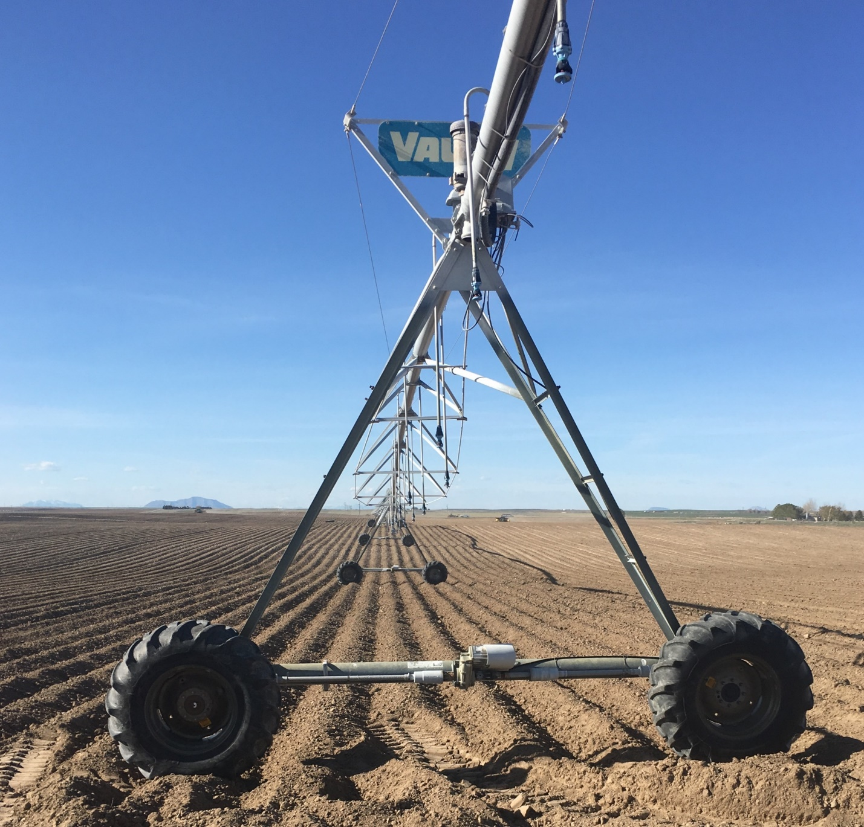
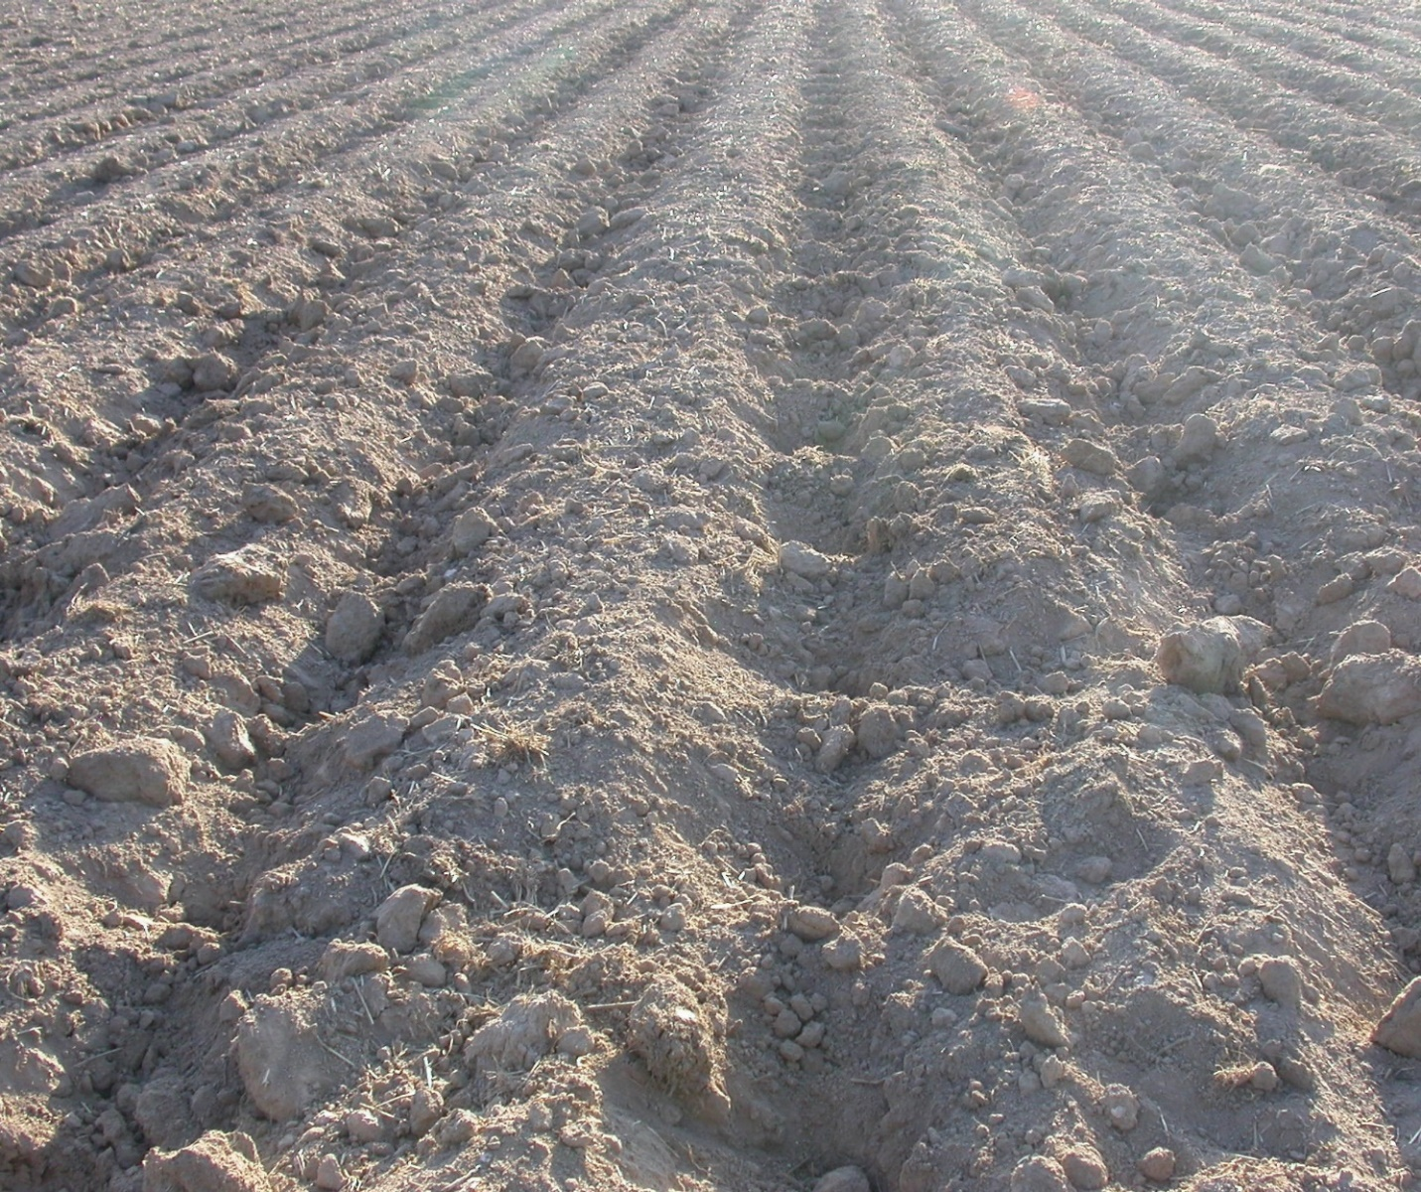

The field is infested with hairy nightshade and common lambsquarters
Figure 1. Preemergence application of metribuzin alone vs metribuzin + Outlook
targeting control of hairy nightshade and common lambsquarters in potatoes
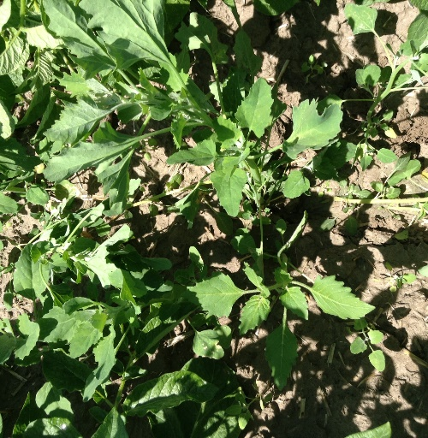
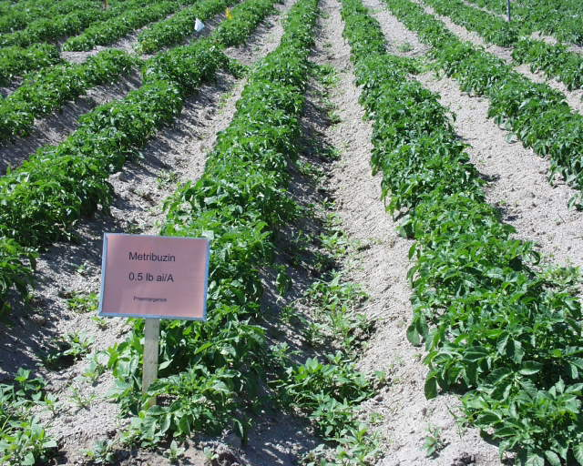
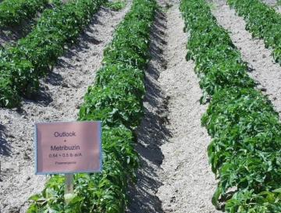
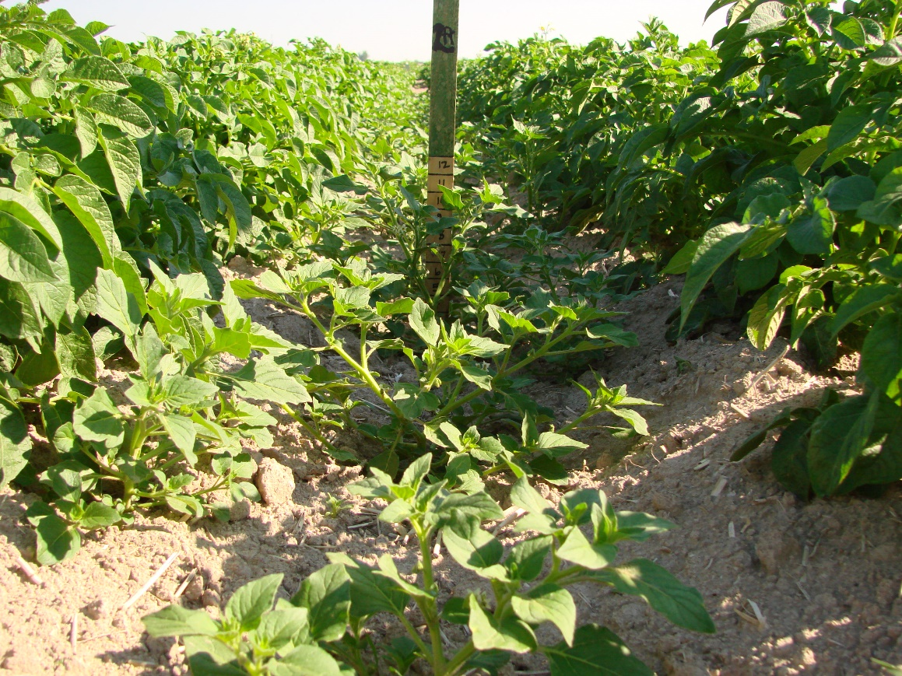
Metribuzin + Outlook provided 100% control of all weeds season long
Metribuzin alone does not control hairy nightshade

Metribuzin applied alone preemergence and sprinkler incorporated with 0.5 in irrigation
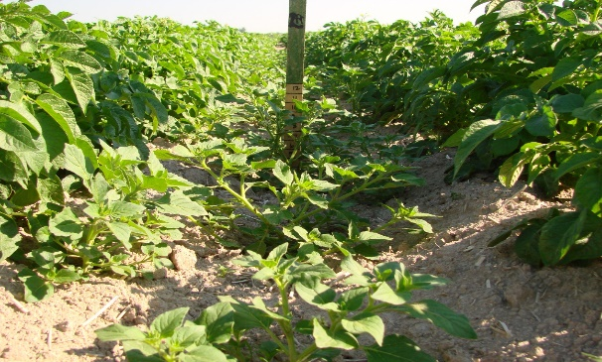

Metribuzin applied alone does not control hairy nightshade

Metribuzin + Outlook
applied preemergence and sprinkler incorporated provided season-long control of hairy nightshade and common lambsquarters
Table 1a. Herbicides labeled for use in potatoes: Effectiveness on broadleaf weeds.
 | Annuals |  |  |  |  |  |  |  |  | Perennials
Herbicides | Kochia | Common lambsquarters | Mustard spp. | Cutleaf nightshade | Black nightshade | Eastern black nightshade | Hairy nightshade | Redroot  pigweed | Russian thistle | Canada thistle | Field bindweed
Chateau (flumioxazin) | S | S | S | S | G | G | G | S | – | N | –
Dual Magnum/  Dual II Magnum (Canada)  (s-metolachlor) | F | F | P | F-G | F | F | F | G | P | N | –
Eptam (EPTC) | P-F | G | P | F-G | G | G | G | F-G | P | P | P
Linex/Lorox (Linuron) | F | G | G | – | – | S | F | G | – | P | –
Matrix or others (rimsulfuron) PRE/POST | G | P/f | G | N | G | G | G | G | P | –/f | P
Prism¹ (rimsulfuron) only POST, Canada only | F-G | S | – | N | – | – | F-G | – | – | – | P
Metribuzin  (several brands)  PRE/POST | G | G | G | P | F | P-F | p/F | G | G | F | P
Outlook (dimethenamid-p) | P-F | P | P | F-G | G | G | G | G | – | – | P
Prowl 3.3 or H2O (pendimethalin) | G-F | F-G | – | P-F | P-F | P-F | F-P | F-G | G | – | P
Reflex (fomesafen) | – | P | G | F | G | G | F | G | – | N | –
Sonalan HFP (ethalfluralin) | F-G | F-G | P | – | F | F | F | G | F-G | – | –
Me-Too-Lachlor or others (metolachlor) | F | F | p | F | F | F | F | G | P | n | –
Sulfentrazone  (various trade names) | G | G | G | G | G | G | G | F-G | G | - | P
Treflan HFP or others (trifluralin) | F-G | F-G | P | P | P | P | P | G | F-G | P | P
Zidua (pyroxasulfone ) | P-F | – | – | – | F-G | F-G | F-G | F-G | – | – | –
Boundary²  (s-metolachlor + metribuzin) | F | f-g | F | f-g | F | F | F | G | f-g | p-f | P
Sencor STZ (Canada) Sulfentrazone MTZ  and other trade names/  (metribuzin + sulfentrazone) | G | G | G | G | G | G | G | G | G | F | P
SEASON LONG CONTROL: G, good = 90 to 100%; F, fair = 80 to 89%; P, poor = 0 to 30%; N, none = 0%; S, suppression only = approx. 50% control; – = no information available.
Adapted from the 2021 PNW Weed Handbook Potato chapter – herbicide effectiveness chart and control ratings are also derived from herbicide labels and potato field research trial results.
Response of weeds to any of the listed herbicides may be altered by growing conditions, weed populations, type of irrigation, genetic variations, soil type, pH, OM, time of application, and application rate. Ratings may vary from season to season and from site to site. Weed control generally decreases as the season progresses.
¹Product used only in Canada. The Prism rate in Canada is 60 g/ha (0.86 oz/A) POST only. Matrix rate range in United States is 1 to 1.5 oz/A PRE or POST.

Table 1b. Herbicides labeled for use in potatoes: Effectiveness on broadleaf weeds not listed in Table 1a.
 | Annuals
Herbicides | Wild buckwheat | Common cocklebur | Prostrate knotweed | Common mallow | Common purslane | Smartweed spp. (annual) | Annual sowthistle | Sunflower, wild
Chateau (flumioxazin) | – | – | – | – | – | – | – | –
Dual Magnum/  Dual II Magnum (Canada)  (s-metolachlor) | P | N | – | F | G | P | P | P
Eptam (EPTC) | F | P | G | P | G | P | F | P
Linex/Lorox (Linuron) | G | S | F | – | G | G | F | –
Matrix or others) (rimsulfuron)  PRE/POST | P | F | N/- | – | –/f | –/f | – | G/f-g
Prism¹ (rimsulfuron) (Canada only)  POST | P | F | – | – | – | – | – | –
Metribuzin  (several trade names)  PRE/POST | g/F | F/g | G | G | G | F | G | F
Outlook  (dimethenamid-p) | P | – | – | – | G | P | P | –
Prowl 3.3 or H2O (pendimethalin) | – | – | G | F | G | F | P | P
Reflex (fomesafen) | N | S | – | – | G | P | – | –
Sonalan HFP (ethalfluralin) | F-G | P | – | – | G | – | – | –
Me-Too-Lachlor,  Stalwart or others (metolachlor) | p | n | – | F | G | P | p | P
Sulfentrazone  (various trade names) | F | F | - | - | G | G | - | -
Treflan HFP or others (trifluralin) | F | P | G | P | G | P-F | P | P
Zidua (pyroxasulfone ) | – | – | – | – | – | – | – | –
Boundary²  (s-metolachlor + metribuzin) | F | S | F | F | G | p-f | F | S
Sencor STZ (Canada) Sulfentrazone MTZ and other trade names  (metribuzin + sulfentrazone) | G | F | G | G | G | G | G | F
SEASON LONG CONTROL: G, good = 90 to 100%; F, fair = 80 to 89%; P, poor = 0 to 30%; N, none = 0%; S, suppression only = approx. 50% control; – = no information available
Adapted from the 2021 PNW Weed Handbook Potato chapter – herbicide effectiveness chart and control ratings are derived from herbicide labels and potato field research trial results.
Response of weeds to any of the listed herbicides may be altered by growing conditions, weed populations, type of irrigation, genetic variations, soil type, pH, OM, time of application, and application rate. Ratings may vary from season to season and from site to site. Weed control generally decreases as the season progresses.
¹Product used only in Canada. The Prism rate in Canada is 60 g/ha (0.86 oz/A) POST only. Matrix rate range in United States is 1 to 1.5 oz/A PRE or POST.

Table 2. Herbicides labeled for use in potatoes: Effectiveness on grass and sedge weeds.
 | Annual grasses |  |  |  |  |  |  |  | Perennial grasses | Sedge  (perennial)
Herbicides | Barnyardgrass | Crabgrass | Foxtail spp. | Sandbur,  field | Barley, volunteer | Oat, volunteer | Oat, wild | Wheat, volunteer | Quackgrass | Nutsedge, yellow
Chateau (flumioxazin) | N | N | N | N | N | N | N | N | N | –
Dual Magnum/  Dual II Magnum (Canada)  (s-metolachlor) | G | G | G | F | – | – | P-F | – | P | F-G
Eptam (EPTC) | G | G | G | G | F-G | F-G | F-G | F-G | F-G | F
Linex/Lorox (Linuron) | F-G | G | G | – | – | – | – | – | P | –
Matrix or others (rimsulfuron) PRE/POST | G | F/g | f-G | – | G | F/G | F/g | G | N/g | –/f
Prism! (rimsulfuron) postemergence only Canada only | G | G | G | – | – | – | – | – | G | –
Metribuzin  (several trade names)  PRE/POST | F/p | F/p | g/F | P | P | g/F | F-G | P | P-F | P
Outlook  (dimethenamid-p) | G | G | G | P-F | F-G | F-G | F-G | F-G | P | F
Prowl 3.3 or H2O (pendimethalin) | G | G | G | – | – | – | F-P | – | – | P
Reflex (fomesafen) | S | S | S | – | S | S | S | S | N | S
Sonalan HFP (ethalfluralin) | G | G | G | G | P | G | F-G | F | P | –
Me-Too-Lachlor or others (metolachlor) | G | G | G | G | – | – | F | – | p | F-G
Sulfentrazone  (various trade names) | N | N | N | N | N | N | N | N | N | G
Treflan HFP or others (trifluralin) | G | G | G | G | P | G | F | F | P | P
Zidua (pyroxasulfone ) | F-G | F-G | F-G | P | – | – | – | – | – | –
Boundary²  (s-metolachlor + metribuzin) | G | G | G | F | P | F | F | p | P | f-g
Metribuzin STZ (Canada)  Sulfentrazone MTZ and other trade names  (metribuzin + sulfentrazone)  Canada only | F | F | G | P | P | G | F | P | P | G
Select (Clethodim) | G | G | G | G | G | G | G | G | G | N
Poast Plus (sethoxydim) | G | F | G | G | G | G | G | G | F | N
Venture¹  (fluazifop-butyl)  Canada only | F | F | G | F | G | G | G | G | G | N
SEASON LONG CONTROL: G, good = 90 to 100%; F, fair = 80 to 89%; P, poor = 0 to 30%; N, none = 0%; S, suppression only = approx. 50% control – = no information available
Adapted from the 2021 PNW Weed Handbook Potato chapter – Herbicide Effectiveness chart and control ratings represent control provided season-long and are derived from herbicide labels and potato field research trial results.
Response of weeds to any of the listed herbicides may be altered by growing conditions, weed populations, type of irrigation, genetic variations, soil type, pH, OM, time of application, and application rate. Ratings may vary from season to season and from site to site. Weed control generally decreases as the season progresses.
¹Product used only in Canada. The Prism rate in Canada is 60 g/ha (0.86 oz/A) POST only. Matrix rate range in United States is 1 to 1.5 oz/A PRE or POST.

Table 3. Potato Herbicides Application Timing and Activity (soil and foliar). 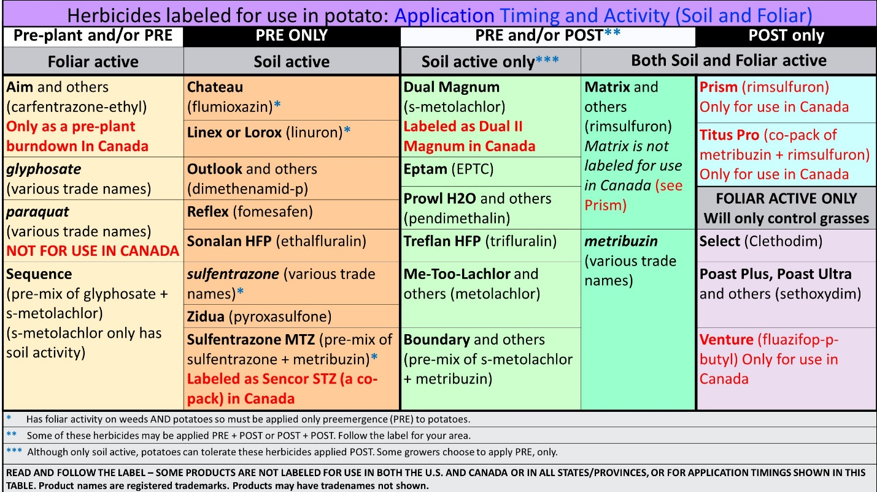

Table 4. Potato Herbicides Strengths and Challenges.
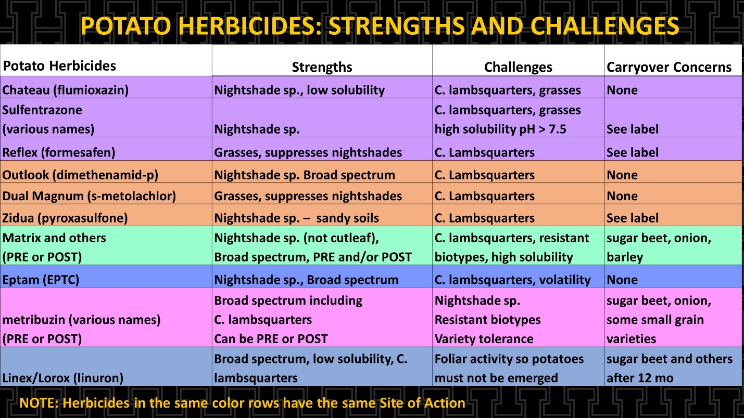

Table 5. Potato Herbicides Strengths and Challenges (cont.)
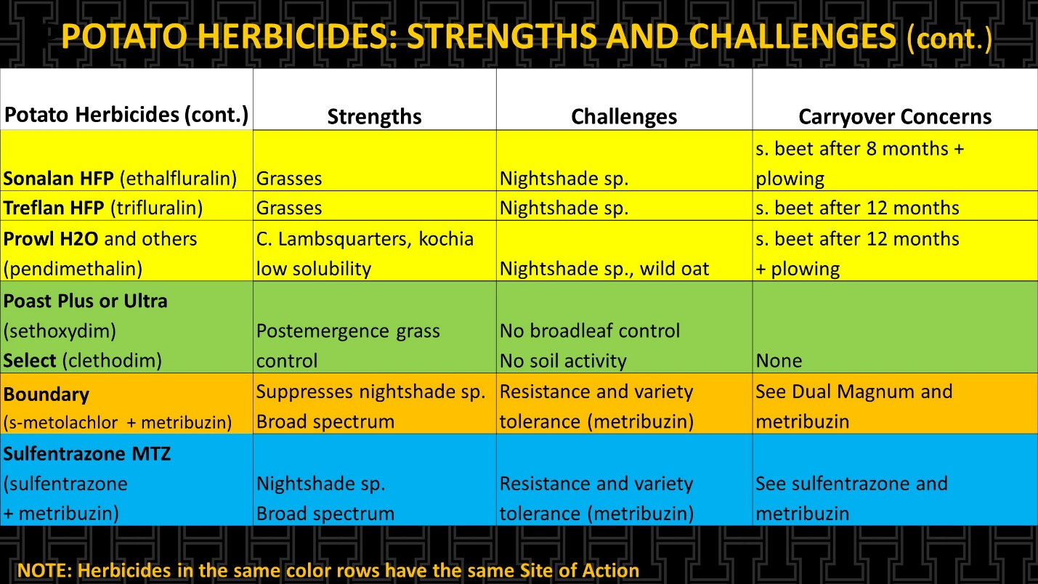

Table 6. Potato Herbicides Strengths and Challenges: Tank mix partners to overcome challenges
